About
Career Development Cell
The Career Development Centre (CDC) plays an integral role in creating the illustrious placement record of VIT. It ensures smooth functioning of the placement activities on the campus. The Centre also facilitates training activities for the students to ensure that they get placed with national and international companies as well. VIT AP has a dedicated Placement and Training (PAT) centre/cell/programme centralized with VIT Career Development Centre for the enhancement of the student’s skills and aptitude.

The VIT placement Cell is committed to offer its students a variety of opportunities to get placed with companies of their choice once their course gets over. Through arranging meetings with professional trainers and VIT alumni, the centre helps the students to prepare themselves for placement interviews in technical and HR aspects and also get well prepared for group discussions. The Career Development Centre (CDC) makes sure that the students get well-versed in Coding and aptitude skills, to perform better in tests and interviews.
CDC Function

Placement Process

Placement Calendrer

Facilities & Training

Placement Policy & Guidelines

Super dream offer
Explore Now

Dream offer
Explore Now

Internship
Explore Now

Statistics
Explore Now

C.D.C Office
Explore Now
Contact Us
Dr. E. Anupriya
Deputy Director (Training)
Dr. Konda Srinivasa Reddy
Assistant Director (Placement)
VIT-AP University, Beside AP Secretariat, Near Vijayawada, 522 237, Andhra Pradesh
Email : placement@vitap.ac.in
Contact Us: 08632370219

Super Dream Offers
In this placement offer, the students are presented with offers with Cost of Company (CTC) of 10 Lakhs and above per annum. Last year, about 140 companies offered 1176 Super Dream placement offers. Among them, Microsoft had offered the highest CTC of 41.60 lakhs per annum. 7 students had received their placement in Microsoft with the Super Dream Offer. This year, we achieved more than double the previous year’s record on Super Dream offers and stand at 2938 Super Dream offers.
The list of final year students who have bagged their Super Dream offer is listed below. As days progress our list shall swell, as we are bringing in the best so that our students are offered the best.

2026 Graduating Batch Students Grab Super Dream Offers





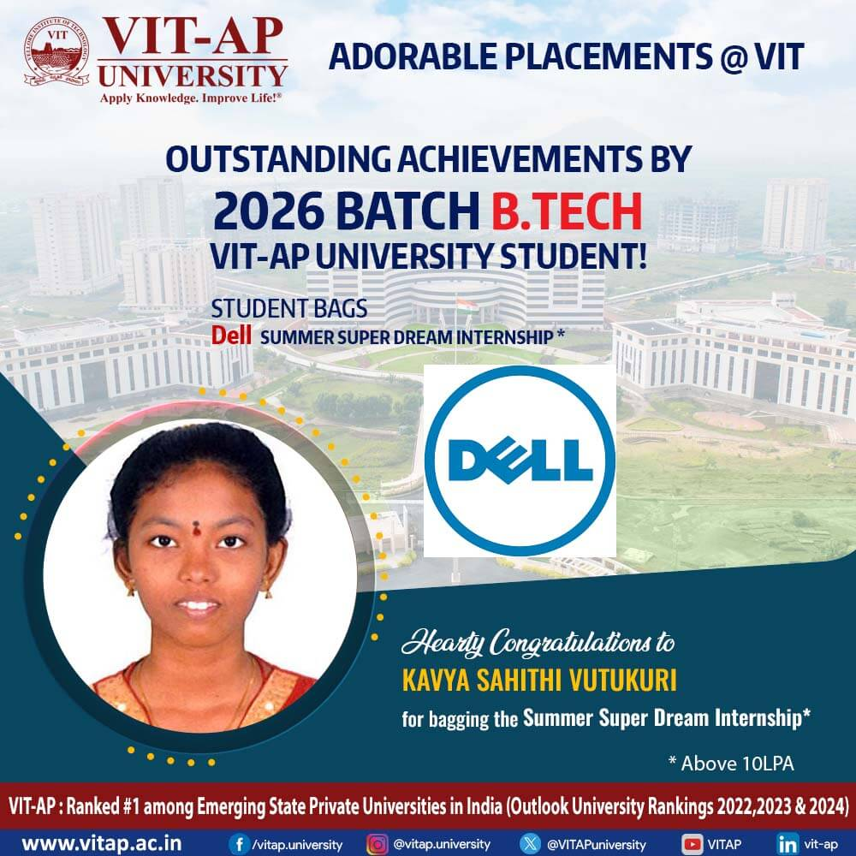

2025 Graduating Batch Students Grab Super Dream Offers
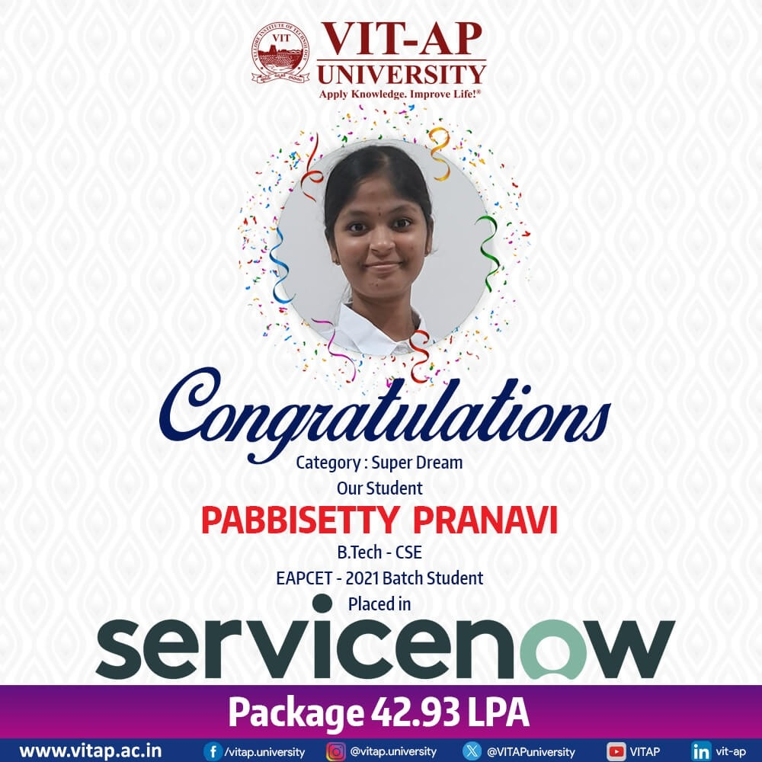

2024 Graduating Batch Students Grab Super Dream Offers

2023 Graduating Batch Students Grab Super Dream Offers

2022 Graduating Batch Students Grab Super Dream Offers

Overview
Explore Now

Dream offer
Explore Now

Internship
Explore Now

Statistics
Explore Now

C.D.C Office
Explore Now
“ INDIA should lead the world. VIT should lead India ”
- Dr. G. Viswanathan, Founder & Chancellor, VIT

Dream Offer
In Dream placement offer, 3836 students are presented with offers with Cost of Company (CTC) of 5.5 Lakhs and above per annum. More than 386 companies have been giving this placement offer to enable students to have multiple choices in the dream placement category. They can choose among various streams including IT Services, product consulting, banking, Core Engineering companies among other options. Such placement opportunities allow the students to freely select the offer that is present in their area of interest.
VIT is a proud holder for the Limca book of records for the highest number of recruitments through placements done from a single institution by IT sector companies for 7 years. Cognizant, TATA Consultancy Services, Accenture, Wipro, and Infosys are a few names in the IT sector that have their placement bases in VIT. These companies have had about 8,000 placements in the year 2016 and the number is increasing every year.
Also, the Career Development Centre in VIT is responsible for internships for students. Apart from placements for students in their final year, the Placement Cell provides international internships with leading MNCs across the globe. An average of 10 students every year get an opportunity to get internships in USA, UK, Ireland, Japan, China, Israel, Taiwan, UAE, Kenya, Germany, Nigeria and Italy. These internship programs help the students to earn a stipend, in addition to hands-on experience and practical application of everything they have learned. While VIT ensures that all its students obtain placement in leading MNCs, it also makes sure that they get internships and have valuable work experience.
The placement season is now growing higher as our students are getting placed with Dream companies. The list of final year students who have bagged their Dream offers is listed below. We are certain that this upward trend with placements will scale higher and our students shall be successfully placed.

Students Grab Dream Offers of Year 2026

Students Grab Dream Offers of Year 2025

Students Grab Dream Offers of Year 2024
Students Grab Dream Offers of Year 2023

Students Grab Dream Offers of Year 2022

Overview
Explore Now

Super dream offer
Explore Now

Internship
Explore Now

Statistics
Explore Now

C.D.C Office
Explore Now
“ INDIA should lead the world. VIT should lead India ”
- Dr. G. Viswanathan, Founder & Chancellor, VIT

VIT-AP Internships
VIT-AP has numerous internship programmes where students can learn about professional fields and get first-hand experience of the work environment even before they reach the actual placements. We work very closely with the industry counterparts and also have a network established with corporates and other universities across the globe that enables our students to gain the experience required for their respective job area, even while being interns.
To boost the placement opportunities VIT-AP has the final semester as the Cooperative Education Programme (co-op). Co-op provides students the opportunity to explore and refine their potential career path. The experience the student gains from this long internship period, narrows the gap with the industry, builds valuable industry connections, broaden their perspectives on the job front, and helps acquire the skills and knowledge required to face the professional world. This co-op makes them strong contenders ready for their job role.
Internships for students of VIT-AP made its way when our first batch of students completed their first academic year. Most of our students went in for internships during the summer break of 2018. This pattern has been continuing in a very positive manner, such that today students register for internships right from their first year of joining a programme at VIT-AP. In 2018, we had students doing international internships at Europe, Colombo, Bahrain, and USA. Since then, we have almost all of our students interning in MNCs.
International Internships
Career Development Centre has been instrumental in providing international internships and placement offers. They have placed at an average of 10 students every year in leading MNCs at USA, UK, Ireland, Japan, China, Israel, Taiwan, UAE, Kenya, Germany, Nigeria, and Italy.

United States

China

Ireland

Japan

Israel

Taiwan

Kenya

Germany

Nigeria

Italy

United Arab Emirates

United Kingdom

Overview
Explore Now

Super dream offer
Explore Now

Dream offer
Explore Now

Statistics
Explore Now

C.D.C Office
Explore Now
Contact Us
Dr. E. Anupriya
Deputy Director (Training)
Dr. Konda Srinivasa Reddy
Assistant Director (Placement)
VIT-AP University, Beside AP Secretariat, Near Vijayawada, 522 237, Andhra Pradesh
Email : placement@vitap.ac.in
Contact Us: 08632370219

Industrial Collaboration

Juniper Networks – Cloud and Automation Academy
The Juniper Networks® Cloud and Automation Academy program is an industry-academic partnership that provides faculty members and students with highly relevant instructional materials, hands-on labs that use industry-leading networking equipment, and even the opportunity to earn an entry-level Juniper certification.

Microsoft Imagine Academy
Microsoft Imagine Academy gives students and educators the curricula and certifications they need to succeed in a technology driven economy. In addition, Microsoft Imagine Academy gives teachers technology skills and helps students succeed through employability and industry certification. VIT-AP University takes advantage of Microsoft Imagine Academy’s curriculum, certifications, professional development, and resources today.

IDS Blockchain academy
IDS collaboration is to impart skill and capabilities to the students in Blockchain Technology and enable them to build their career in this emerging field. This will also provide an opportunity to the students, scholars, and faculty members to carry out research and to develop several advanced applications using Blockchain Technology. Further, IDS will provide internships with financial support, and job opportunities to selected students of VIT-AP University.

Boston IT Solutions
This collaboration is intended to cover specific collaborative efforts between Boston and VIT AP under the Boston Training Academy (BTA) driven by Boston. BTA will facilitate development opportunities in industry collaboration in the field of Artificial Intelligence and Data Science. This is aimed at providing hands-on learning opportunities to the students, exchange of resources, and knowledge sharing between the institutions.

Palo Alto Networks Cybersecurity Academy
Palo Alto Networks Education Services develops world-class cybersecurity training and curriculum. Palo Alto Networks Authorized Training Partners (ATPs) deliver Palo Alto Networks Authorized training courses in classroom and virtual delivery formats through public open enrolment and private onsite trainings.

Automation Anywhere Academy
We partnered with Automation Anywhere to help the learners build Robotic Process Automation capabilities. Digital workers have emerged as a great assistant to human employees and have enable them to unleash their real potential at work by eliminating mundane tasks. RPA has started shifting the gears of Indian industries, making the skill even more desired. We thank Automation Anywhere for joining hands with us in the journey to build the future digital India.

Red Hat Academy
We partnered with Automation Anywhere to help the learners build Robotic Process Automation capabilities. Digital workers have emerged as a great assistant to human employees and have enable them to unleash their real potential at work by eliminating mundane tasks. RPA has started shifting the gears of Indian industries, making the skill even more desired. We thank Automation Anywhere for joining hands with us in the journey to build the future digital India.

Cisco Networking Academy
Cisco Networking Academy transforms the lives of learners, educators and communities through the power of technology, education, and career opportunities. It is available to anyone, anywhere.

UiPath Academic Alliance – RPA Academy
UiPath Academy enriches knowledge in the world of automation. UiPath academy enables RPA developers to quickly and easily implement robots that use a combination of ground-breaking Computer Vision and UI-selector technology to navigate applications and mimic user actions to automate end-to-end business processes

AWS Academy
Through AWS Educate, students and educators have access to content and programmes developed to skill up for cloud careers in growing fields. AWS Educate also connects companies hiring for cloud skills to qualified student job seekers with the AWS Educate Job Board

Tata Consultancy Services (TCS)
TCS offers B.Tech. in Computer Science and Business Systems Program (Suggested: VIT-AP offers B.Tech. in Computer Science and Business Systems Program in collaboration with TCS). Through TCS, the students and educators enhance their employability skills by making themselves capable of using the latest computer technology.

Career Development Center
Vellore Institute of Technology promises placements to all its students in established MNCs. The Career Development Centre of VIT, or CDC Office, offers students a variety of opportunities in placement of jobs to choose from, after their course comes to an end. The Career Development Centre plays an integral role in creating the illustrious placement record of VIT. It ensures smooth functioning of the placement activities in the campus. The Centre further facilitates training activities of the students and makes sure they get placed in the best of both national and international companies.
In 2021-22 alone, CDC had brought more than 800 companies on campus for placements. Last year, the highest offer made was 39 lakhs per year by Microsoft. Over the recent years, many reputed companies such as Intel, eBay, Amazon, Dell, GE, Texas Instruments, Schneider Electric, DE Shaw & Co, Hitachi, HP, PayPal, Tata Motors, L&T, Dr. Reddy’s, Bosch, Deloitte, Morgan Stanley, Qualcomm, Ashok Leyland, Honda, Ford, Global Analytics, TCS, Cognizant, Accenture, Wipro, and InfoSys have participated in hiring from VIT.
Objectives
The key responsibilities of the Career Development Centre are listed below:
★ To organize campus interviews for final year students with industries and business houses of repute from all over India.
★ To prepare students to face campus interviews by arranging training in aptitude tests, group discussions, and preparing for Technical and HR interviews through professional trainers and VIT alumni.
★To promote career counselling by organizing guidance lectures by senior corporate personnel and most importantly, by the immediately placed senior students.
Leadership

Dr.V. Samuel Rajkumar
Director - CDC

Dr. Anupriya Elumalai
Deputy Director, CDC

Dr. Srinivasa Reddy Konda
Assistant Director, CDC
Coordinators

Dr. M M V Chalapathi
Training Coordinator, SCOPE

Dr. Anoop Kumar Mishra
Training Coordinator, SENSE

Dr. Gurumurthy Komanapalli
Training Coordinator, SENSE

Dr. Kishor E
Training Coordinator, SMEC

Dr. Shaiku Shahid Saheb
Training Coordinator, VSB
Placement Officer

Mr. Grandhe Venkata Karthik
Placement Officer, CDC
Secretaries

Ms. Ravuri Raga Chandrika
Senior Secretary, CDC

Ms. Nandivada Varshini
Senior Secretary, CDC

Mr. Mandepudi Chaitanya
Secretary, CDC

Overview
Explore Now

Super Dream offer
Explore Now

Dream Offer
Explore Now

Internship
Explore Now

Statistics
Explore Now
Statistics

Super Dream & Dream Offers

Total Students Placed

Number of Companies Visited

Recruiters

Overview
Explore Now

Dream offer
Explore Now

Internship
Explore Now

SuperDream
Explore Now
C.D.C Office
Explore Now
“ INDIA should lead the world. VIT should lead India ”
- Dr. G. Viswanathan, Founder & Chancellor, VIT

